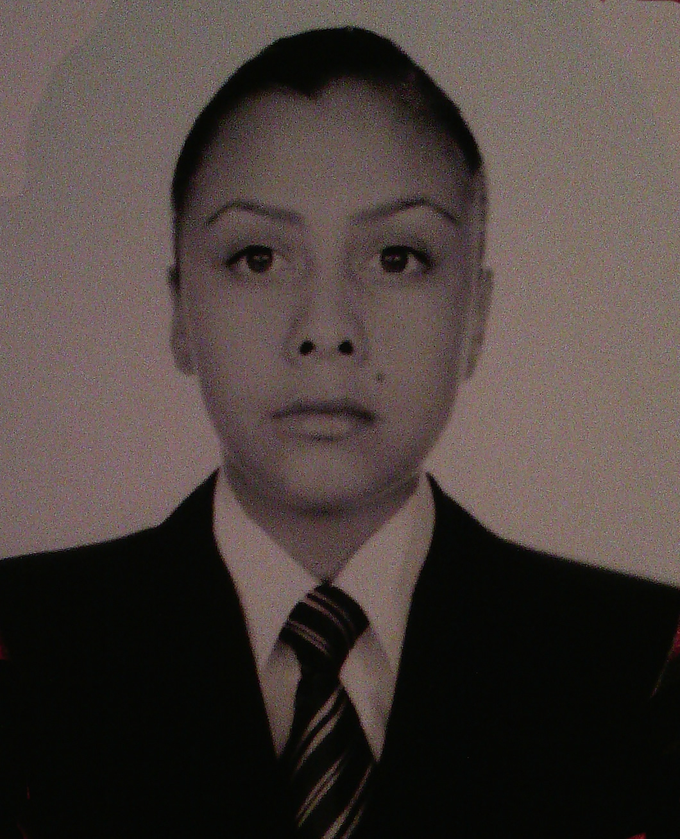

**Name:** María Guadalupe Caballero Cruz.

**Birthdate:** 30-Junio-1996 **Age:** 20

**CURP:** CACG960630MMNBRD08

**Address:** Calle San Ignacio s/n, Localidad Ucareo, 58962,

Zinapécuaro, Michoacán.

**Phone:** 447-126-35-87

**Email:** [magpe.informatica@gmail.com](mailto:magpe.informatica@gmail.com)

**Civil Status:** Single

**Nacionalidad:** Mexicana

**PROFESSIONAL OBJECT IVE**

To be part of a medium-term work team and consolidate myself professionally in a company, where I can play my knowledge and skills to grow in the workforce, personal and intellectual.

**PERSONAL OBJECTIVE**

Be a committed and motivated person with my personal growth in the short term taking courses of personal improvement that allow me to grow as a person and professional.

**ACADEMIC FORMATION**

* + Universidad Tecnológica de León, Unidad Académica del Sureste.

**Career:** Ingeniería en Tecnologías de Información y Comunicación.

**Year:** September 2016 y **Currently:** Studying.

**Address:** Carretera Acámbaro-Tarandacuao, km 8, Colonia San Miguel del Puerto.

**Phone:** 15-50-600

* + Universidad Tecnológica de León, Unidad Académica del Sureste.

**Career:** Técnico Superior Universitario en Tecnologías de Información y Comunicación.

**Tittle:** In the process.

**Average:** 9.4

**Year:** September 2014 – August 2016.

**Address:** Carretera Acámbaro-Tarandacuao, km 8, Colonia San Miguel del Puerto.

**Phone:** 15-50-600

* + Colegio de Bachilleres del Estado de Michoacán #36, Plantel: Ucareo-Jerahuaro.

**Career:** Certificado Técnico en administración de la pequeña empresa.

**Average:** 9.2

**Year:** August 2011 – July 2014

**Address:** Carretera a Ucareo-Morelia, km .5, Municipio Zinapécuaro, en el Estado de Michoacán.

* + Escuela Secundaria Técnica #35.

**Career:** Certificado.

**Average:** 9

**Year:** August 2008 – July 2011

**Address:** Carretera a Ucareo-Morelia, km .5, Municipio Zinapécuaro, en el Estado de Michoacán.

**WORK EXPERIENCE**

* + **Company name:** Clínica Dental de Especialidades.

**Job:** Programmer.

**Period:** May - August 2016.

**Main activities:**

Development of the Web Application ‘Clínica Dental de Especialidades’ that allows for the management of the patients, as well as the treatments that are made to these same; this application was developed using the PHP programming language and for the protection of the information was made using a System Database Manager as MySQL.

**COMPUTERS SKILLS**

* + Programming language:
    - PHP (85%), Java (85%).
  + System software:
    - Operating systems [Windows (95%), Linux(75%)].
  + Programming software:
    - Netbeans (90%), StarUML (85%), Sublime Text (95%).
  + Application Software:
    - Office [Microsoft Word, Power Point (98%), Excel (95%), Publisher (90%), Visio (85%), Project (80%)].
    - Audio editors [Sound Forge (80%), Audacity (80%)].
    - Image editors [Macromedia Fireworks 8 (95%), CorelDRAW X7 (80%), Photoshop (70%)].
    - Video editors [Camtasia Studio8 (95%), Adobe Premiere (90%)].
    - Data Base Management System (MySQL (80%), Microsoft SQL Server (70%)).
    - Others programs [Adobe Director (85%), Blender (80%), Local Servers as XAMPP y WAMP (85%), FileZilla (80%), Dia (90%), Balsamiq Mockups (80%), Workbench (90%), WordPress (90%), among others].

**OTHER DATA OF INTEREST**

During my formation academic I have programming language as PHP and Java; as well as the use of the Data Base Management System for the storage, modification and extraction of information in a database.

Moreover, I reinforced som knowledge as to the edition of video, audio and image; as well as the use of the others programs for the design of diagrams, the production of exevutable multimedia programs, 3D animations, among others.

**TIME AVAILABILITY**

I have a full time availability, so I consider myself as a responsible and honest person because I like to perform in the best way in a job.